HMS Mirror and Automation Setup

HMS Mirror Setup

Login to edge node:
Go to /tmp
wget https://github.com/cloudera-labs/hms-mirror/releases/download/3.1.0.1/hms-mirror-3.1.0.1-dist.tar.gz

Or download from this location

Download HMS Mirror from this location
https://github.com/cloudera-labs/hms-mirror/releases/tag/3.1.0.1

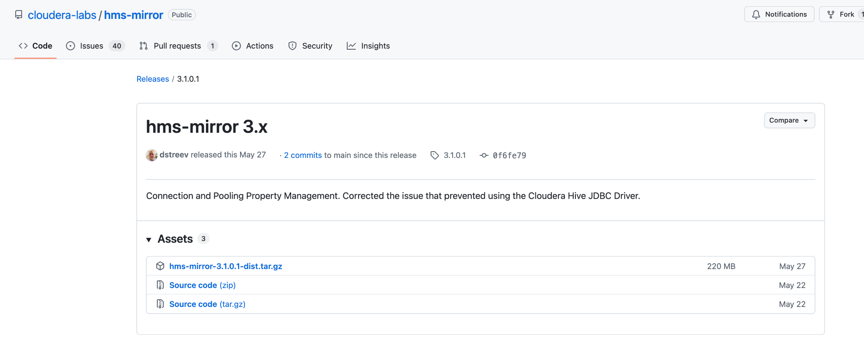

HMS mirror setup must be done as root user under /root directory

- Remove previous install directory rm -rf hms-mirror-install
- Expand the tarball tar zxvf hms-mirror-3.1.0.1-dist.tar.gz.

This produces a child folder hms-mirror-install-3.1.0.1

directory.
- Two options for installation:
  - As the root user (or sudo), run hms-mirror-install-3.1.0.1/setup.sh. This will install the hms-mirror packages in /usr/local/hms-mirror and create symlinks for the executables in /usr/local/bin. At this point, hms-mirror should be available to all user and in the default path.
DO NOT RUN hms-mirror from the installation directory.

step1:
sudo hms-mirror-install-3.1.0.1/setup.sh

Step2:
This requires jdk17
export JAVA_HOME=/opt/jdk-17
export PATH=$JAVA_HOME/bin:$PATH

hms-mirror --setup

[root@vvs-baseiq-1 tmp]# hms-mirror --setup
APP_DIR: /usr/local/hms-mirror/bin
Running Host instance
Application JAVA_OPTS=-Xms4096m -Xmx8192m -XX:+UseG1GC -Duser.home=/root -Dlogging.threshold=INFO -Dlogging.filename-prefix=hms-mirror
PRG_ARGS= --setup
Using Java Version:
openjdk version "11.0.3" 2019-04-16 LTS
OpenJDK Runtime Environment Zulu11.31+11-CA (build 11.0.3+7-LTS)
OpenJDK 64-Bit Server VM Zulu11.31+11-CA (build 11.0.3+7-LTS, mixed mode)
CLI_CMD: /usr/java/default/bin/java -Xms4096m -Xmx8192m -XX:+UseG1GC -Duser.home=/root -Dlogging.threshold=INFO -Dlogging.filename-prefix=hms-mirror -jar /usr/local/hms-mirror/bin/../lib/*-standalone.jar
13:37:35.790 [main] INFO com.cloudera.utils.hms.mirror.cli.Mirror - Translating command line arguments to Spring Boot arguments
13:37:35.885 [main] INFO com.cloudera.utils.hms.mirror.cli.Mirror - Translated Spring Boot arguments: --spring.main.web-application-type=none --hms-mirror.config.setup=true --hms-mirror.config.legacy-command-line-options=" --setup"
13:37:35.887 [main] INFO com.cloudera.utils.hms.mirror.cli.Mirror - STARTING THE APPLICATION
2025-10-23 13:37:39,660 INFO [main] [c.c.u.h.m.c.HmsMirrorCommandLineOptions]: beta: true
2025-10-23 13:37:39,661 INFO [main] [c.c.u.h.m.c.HmsMirrorCommandLineOptions]: legacy-command-line-options: " --setup"
2025-10-23 13:37:39,661 INFO [main] [c.c.u.h.m.c.HmsMirrorCommandLineOptions]: setup: true
----------------------------------------------------------------
.... Default Config not found. Setup default config.
----------------------------------------------------------------
Setup LEFT cluster....
What is the 'namespace' for the LEFT cluster? (EG: hdfs://myclusterHA or hdfs://host07:8020)
hdfs://ns1
What is the platform type for the LEFT cluster? ([CDH5, CDH6, CDP7_0, CDP7_1, CDP7_1_9_SP1, CDP7_2, CDP7_3, HDP2, HDP3, MAPR, EMR, APACHE_HIVE1, APACHE_HIVE2, APACHE_HIVE3, APACHE_HIVE4]CDP7_1_9_SP1
What is the JDBC URI for the LEFT cluster? jdbc:hive2://vvs-baseiq-1.vpc.cloudera.com:2181/default;principal=hive/_HOST@QE-INFRA-AD.CLOUDERA.COM;serviceDiscoveryMode=zooKeeper;ssl=true;sslTrustStore=/var/lib/cloudera-scm-agent/agent-cert/cm-auto-global_truststore.jks;trustStorePassword=pXmtL1MtFBlYxQGk3oA7iDM8daXzLxRS9jn27HpYAAd;trustStoreType=jks;zooKeeperNamespace=hiveserver2
----------------------------------------------------------------------------------------
The connections ALSO appears to be Kerberized.
>> Will your Kerberos Ticket be TRUSTED for BOTH JDBC Kerberos Connections? (Y/N)
Y
>> Are both clusters running the same version of Hadoop/Hive? (Y/N)
Y
----------------------------------------------------------------------------------------
What is the location (local) of the 'hive standalone' jar file?
/opt/cloudera/parcels/CDH-7.1.9-1.cdh7.1.9.p1032.65742178/lib/hive/lib/hive-standalone-metastore-3.1.3000.7.1.9.1032-3.jar
----------------------------------------------------------------------------------------
** A direct link to the metastore database allows for efficient collection of
partition location metadata, which is a vital part of some migration strategies
that need to work on partition movements. Without this, you may not have all
the information needed to complete the migration under certain conditions and
the functionality will be limited. **
----------------------------------------------------------------------------------------
Would you like to define the 'metastore direct' link? (Y/N)
N
Setup RIGHT cluster....
What is the 'namespace' for the RIGHT cluster? (EG: hdfs://myclusterHA or hdfs://host07:8020)
hdfs://ns1
What is the platform type for the RIGHT cluster? ([CDH5, CDH6, CDP7_0, CDP7_1, CDP7_1_9_SP1, CDP7_2, CDP7_3, HDP2, HDP3, MAPR, EMR, APACHE_HIVE1, APACHE_HIVE2, APACHE_HIVE3, APACHE_HIVE4]CDP7_1_9_SP1
What is the JDBC URI for the RIGHT cluster? jdbc:hive2://vvs-baseiq-1.vpc.cloudera.com:2181/default;principal=hive/_HOST@QE-INFRA-AD.CLOUDERA.COM;serviceDiscoveryMode=zooKeeper;ssl=true;sslTrustStore=/var/lib/cloudera-scm-agent/agent-cert/cm-auto-global_truststore.jks;trustStorePassword=pXmtL1MtFBlYxQGk3oA7iDM8daXzLxRS9jn27HpYAAd;trustStoreType=jks;zooKeeperNamespace=hiveserver2
----------------------------------------------------------------------------------------
The connections ALSO appears to be Kerberized.
>> Will your Kerberos Ticket be TRUSTED for BOTH JDBC Kerberos Connections? (Y/N)
Y
>> Are both clusters running the same version of Hadoop/Hive? (Y/N)
Y
----------------------------------------------------------------------------------------
What is the location (local) of the 'hive standalone' jar file?
/opt/cloudera/parcels/CDH-7.1.9-1.cdh7.1.9.p1032.65742178/lib/hive/lib/hive-standalone-metastore-3.1.3000.7.1.9.1032-3.jar

Set created tables to 'auto-discover' partitions?(Y/N)
N
Run 'MSCK' after table creation?(Y/N)
N

hms-mirror –service (with default port)

If default port is already used by other process use below cmd with unused port.
hms-mirror --service --server.port=8095

http://<replace with hms mirror host>:8090/hms-mirror

Take backup of Metastore database in Mysql
Add whitelisting for tez\.grouping\..* in Hive on Tez for whitelisting. This is one
time setup

This allows HMS Mirror to pass Tez-specific configuration properties when executing queries.

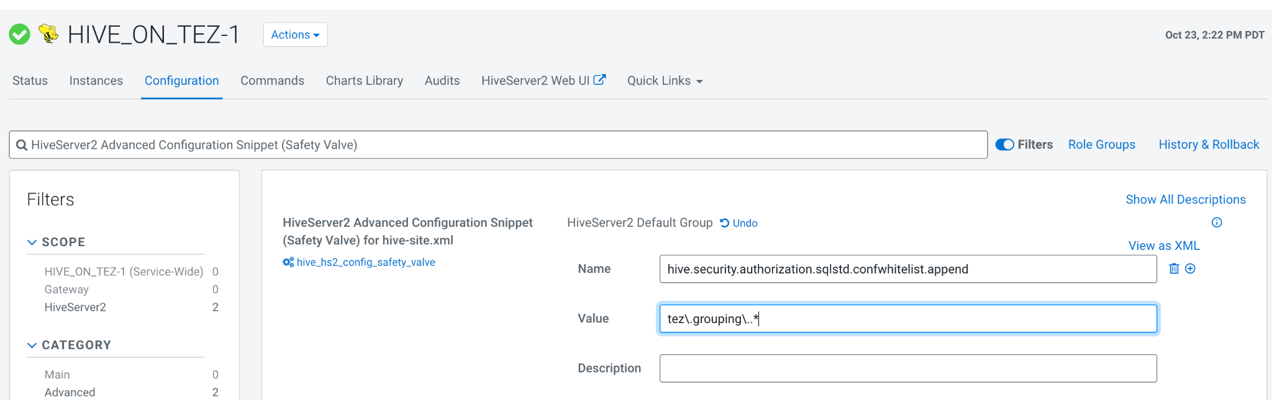

6. Identify yarn queue to execute SQL provided by HMS-Mirror for migration.

7.. Make sure to add “Hive” ( Or any other user who will be executing HMS-mirror) user under Deny rule in Ranger for policy All Volume,Bucket only. This will make sure that unwanted volumes will not get created automatically when executing SQL
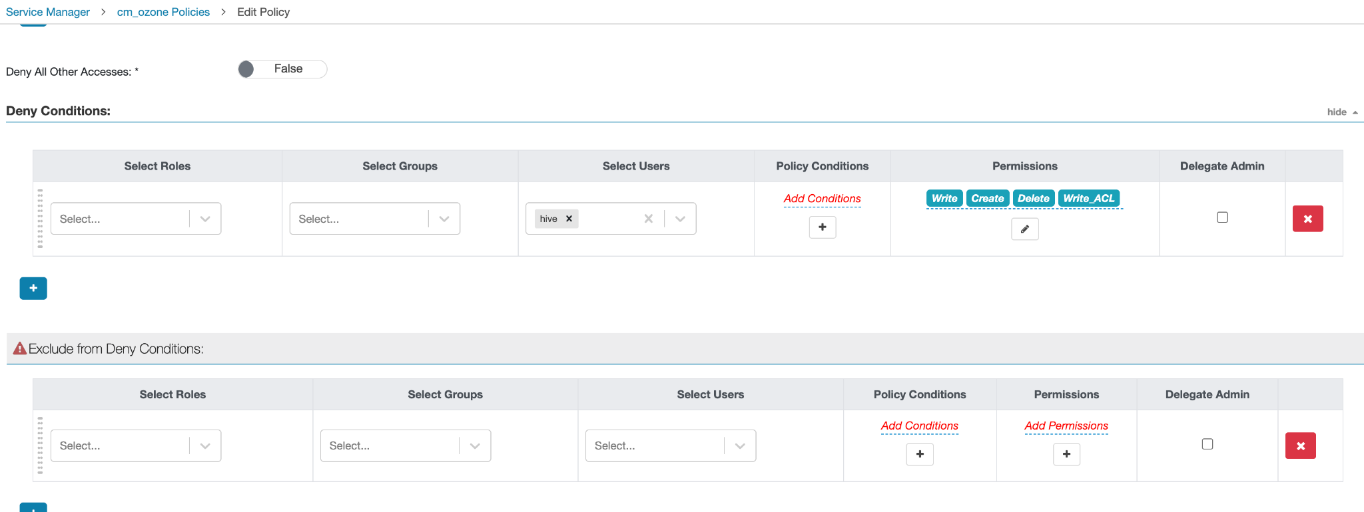

Quick Start

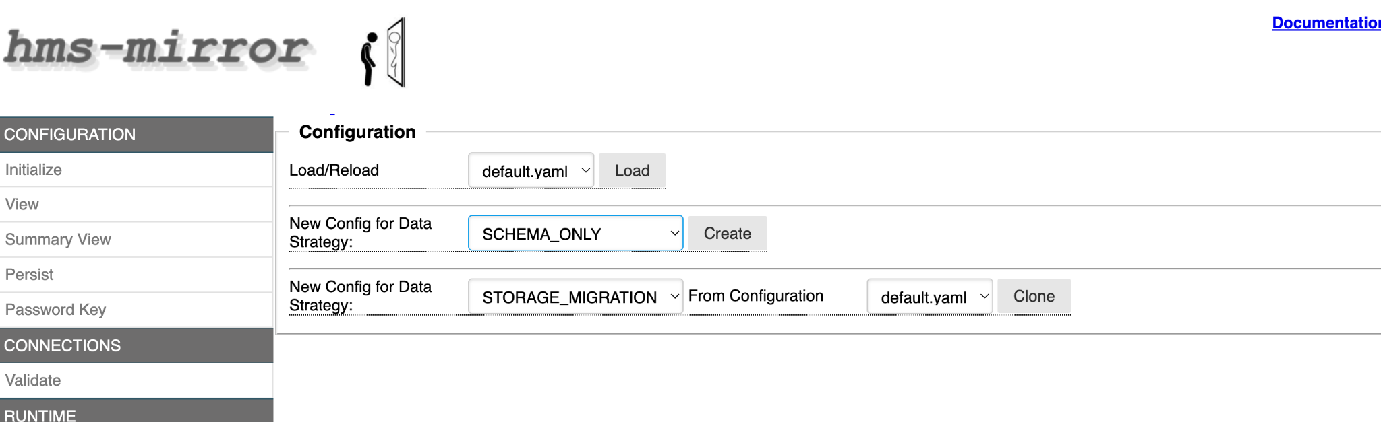

Post initial setup:

You would see below folder with default.yaml file

/root/.hms-mirror/cfg

Copy following attached yaml files to /root/.hms-mirror/cfg

2025-11-12_23-02-06_Storage_Migration.yaml

2025-11-13_00-03-02_schema_only_latest_nov13.yaml

Click on Load/Reload individual yaml files

Update the below settings as per citi cluster configuration

hiveServer2:
uri: "jdbc:hive2://vvs-baseiq-1.vpc.cloudera.com:10000/default;principal=hive/_HOST@VPC.CLOUDERA.COM;ssl=true;sslTrustStore=/var/lib/cloudera-scm-agent/agent-cert/cm-auto-global_truststore.jks;trustStorePassword=pXmtL1MtFBlYxQGk3oA7iDM8daXzLxRS9jn27HpYAAd;trustStoreType=jks"

jarFile: "/opt/cloudera/parcels/CDH/jars/hive-jdbc-3.1.3000.7.1.9.1032-3-standalone.jar:/opt/cloudera/parcels/CDH/jars/log4j-1.2-api-2.18.0.jar:/opt/cloudera/parcels/CDH/jars/log4j-api-2.18.0.jar:/opt/cloudera/parcels/CDH/jars/log4j-core-2.18.0.jar"
version: "3.1.3000.7.1.9.1032-3"
metastore_direct:
uri: "jdbc:mysql://vvs-baseiq-1.vpc.cloudera.com:3306/hive1"
type: "MYSQL"
initSql: ""
resource: "/root/.hms-mirror/aux_libs/mysql-connector-java.jar"
connectionProperties:
password: "Test@123"
user: "hive13mhnezngm"

In case of hiveServer2 uri Use Thrift url instead of zookeeper,
update jarFile locations based on citi paths and
download mysql-connector-java.jar to /root/.hms-mirror/aux_libs/ and provide the path

Also update metastore_direct connection url based on citi env.

Goto Persist -> click Persist with un-selecting check boxes

Go to CONNECTIONS->validate click validate

Go to RUNTIME->execute ->click dry run

At the end it will persist the changes to the existing yaml files

Ozone volume and bucket creation

Prerequisites

- Install python ‘request’ module on Linux host where this script will be deployed if not exists

python -c "import requests; print('requests is installed, version:', requests.__version__)"

pip install requests

CreateOzoneVolumesAndBuckets.py
This script creates Ozone volumes and buckets corresponding to HDFS FID directories which is the prerequisite for hms-mirror automation scripts

1.1 Default Run
In the default run, the script scans all directories under /data and creates corresponding volumes and buckets. No fids need to be provided as input. Only the configuration file that looks like below will be provided to the script.

- Sample conf file createScriptConf.txt has entries like,update this as per citi config.

fid_dir_prefix=/data/
volumeOwner=hdfs
run_directory=.
keytab_path=/root/hdfs.keytab
principal=hdfs/ccycloud-1.mala-ozone.root.comops.site@ROOT.COMOPS.SITE

default_volume_quota=12GB
buckets=raw|managed|work
encrypted=N
replication_type=RATIS
layout=FILE_SYSTEM_OPTIMIZED

The fid_dir_prefix is a parent HDFS directory that hosts all FID directories at the first level.
The volumeOwner is a user ID that is either a superuser in Ozone config or has read/write/execute ranger policy for all volumes and buckets.
The run_directory is where the script log file HDFS2OzoneNamespace.log and script output file ozoneCreateScript.sh will be stored

- Sample command to invoke dryrun of the script :
./CreateOzoneVolumesAndBuckets.py -f createScriptConf.txt -r

- Sample command to invoke the script :
./CreateOzoneVolumesAndBuckets.py -f createScriptConf.txt

Custom run with create-parameters-list as input

- Sample command to invoke the script providing custom parameters for each volume:
./CreateOzoneVolumesAndBuckets.py -f createScriptConf.txt -c customCreateInput.txt -r

./CreateOzoneVolumesAndBuckets.py -f createScriptConf.txt -c customCreateInput.txt

- Sample input file customCreateInput.txt has entries like this:
FID1, 1gb, raw|managed|work, N, RATIS, FILE_SYSTEM_OPTIMIZED
FID2, 2gb, raw|managed|work, N, RATIS, FILE_SYSTEM_OPTIMIZED
FID3, 3gb, raw|managed|work, N, RATIS, FILE_SYSTEM_OPTIMIZED

HMS-Mirror Tool ( HDFS to ozone) Automation

Note:This tool works with external hive tables,if the schema has iceberg tables need to exclude those,need a separate tool to migrate those iceberg tables to ozone

How to :

export JAVA_HOME=/opt/jdk-17
export PATH=$JAVA_HOME/bin:$PATH

kinit hive.keytab <hive-principal>

All the inputs to tool are kept in “input_file.conf” which needs to be co-located where python code will be kept on server for execution

host=<MySQL HOST> ==> MySQL server name
user=<Username> ==> MySQL username
password=<Password> ==> MySQL password
connect_db=<Hive Metastore DB> ==> Name of Metastore DB in MySQL
query_db="<comma separated list of DB_name to be migrated>"
create_table_exclude_list="true" ==> Flag to create list of table to be skipped
DB_NAME="<comma separated list of DB_name to be migrated>"
OZ_NAME="<OFS Nameservice>"
EWD_NAME="<Pipe separated list of External warehouse dir for DB in Ozone>"
MAN_NAME="<Managed Warehouse dir for DB>"
HDFS_EWD_NAME="<Pipe separated list of External warehouse dir for DB in HDFS>"

Sample for “hdfs_db4,hdfs_db5” db’s

host=hostname
user=user
password=password
connect_db=hive1

query_db="hdfs_db4,hdfs_db5"
create_table_exclude_list="true"
DB_NAME="hdfs_db4,hdfs_db5"
OZ_NAME="ofs://ozone1756774157"
EWD_NAME="/fid2/raw/hive|/fid2/managed/hive"
MAN_NAME="/warehouse/tablespace/managed/hive"
HDFS_EWD_NAME="/data/fid2/raw/hive|/data/fid2/managed/hive"
OZONE_PREFIX="ozone_"

HDFS_EWD_NAME is used in “wps” mapping which maps location in HDFS ( for e.g. /data/test/raw/hive) to EWD_NAME in Ozone ( /test/raw/hive) so that all DB and tables in Ozone will point to /dio….

Scripts:

As part of execution you will need to execute below 2 scripts.

get_table_exclusion_list.py
This will give you a list of tables for a particular database for which table location is outside its corresponding DB location. These tables will be excluded in the further execution as they are not within DB location.

Executed as:

python3 get_table_exclusion_list_v2.py -i input_file.conf

If create_table_exclude_list="true" is set to true in input_file.conf it will add
TABLES_EXCLUDE_LIST="test_7|test_8" in the same file ( input_file.conf ) which next script will read to exclude the tables in HMS-MIrror execution

If it's set to false we can get the output in ./reports/run_get_table_exclusion_list_20241030_195938/create_table_exclude_filter_list_output.txt

hms_mirror_executor_updated_v4.py

- This tool automates the process of migrating Hive databases from HDFS to Ozone storage using HMS Mirror. It generates optimized commands, executes them, and post-processes the generated SQL files for clean deployment.

Requirements

Software
- Python 3.6 or higher
- HMS Mirror (in PATH)
- MySQL client (for table exclusion feature)
- Bash 4.0+ (for standalone SQL processor)

HMS Mirror Configuration
- YAML configuration files for both data strategies:
  - STORAGE_MIGRATION config
  - SCHEMA_ONLY config
- Hadoop classpath configured

Network Access
- MySQL database connectivity
- HDFS/Ozone storage access
1. Validate hms-mirror-cmds:

python3 hms_mirror_executor_updated_v4.py -c input_file.conf --generate-scripts --validate-hms-mirror-cmds

2. Generate Scripts for Intra and in-place migration:
python3 hms_mirror_executor_updated_v4.py -c input_file.conf --generate-scripts
Note:Update the required FID raw,managed,reports db base paths and target db ozone prefix id,and source cluster ozone service id
Also this will create an unprocessed_parent_folders_report.txt contains list of folders not processed by hms-mirror as they dont have any db’s associated.

hms_mirror_output_20260105_103429/unprocessed_parent_folders_report.txt

3. Generate Scripts for Inter cluster migration:

python3 hms_mirror_executor_updated_v4.py -c input_file.conf --generate-scripts --distcp-script /root/ozone-migration-main/hdfs2ozone_inter_cluster.sh --distcp-config /root/ozone-migration-main/input_param.conf

Note:Update the required FID raw,managed,reports db base paths and target db ozone prefix id,and target cluster ozone service id
Alsp provide paths hdfs2ozone_inter_cluster.sh and input_param.conf
Update the input_param.conf with target ozone cluster ozone details based on ozone-site.xml of target cluster
Actual Migration steps for Intra cluster:

Make sure to run
./CreateOzoneVolumesAndBuckets.py -f createScriptConf.txt -c customCreateInput.txt (with custom volume quota defined in customCreateInput.txt )

./CreateOzoneVolumesAndBuckets.py -f createScriptConf.txt (With default volume quota of 14 gb)

For each of the DB

cd /root/.hms-mirror/reports/2025-11-13_09-53-47/hdfs_db4_STORAGE_MIGRATION
chmod 755 *.sh
Dist cp cmd:
./hdfs_db4_LEFT_distcp_script.sh
Validate whether data has been copied:
hdfs dfs -ls -R ofs://ozone1756774157/<fid>
Prepare beeline cmd using RIGHT_execute_transformed.sql

beeline -u "jdbc:hive2://vvs-baseiq-1.vpc.cloudera.com:10000/default;principal=hive/_HOST@VPC.CLOUDERA.COM;ssl=true;sslTrustStore=/var/lib/cloudera-scm-agent/agent-cert/cm-auto-global_truststore.jks;trustStorePassword=pXmtL1MtFBlYxQGk3oA7iDM8daXzLxRS9jn27HpYAAd;trustStoreType=jks" -f /root/.hms-mirror/reports/2026-01-05_10-47-11/hdfs_db4_SCHEMA_ONLY/hdfs_db4_RIGHT_execute_transformed.sql --force=true 2> /tmp/sqllog2.log

Actual Migration steps for Inplace migration:

drop database ozone_hdfs_db5 cascade;
drop database ozone_hdfs_db4 cascade;

Prepare beeline cmd using LEFT_execute.sql
beeline -u "jdbc:hive2://vvs-baseiq-1.vpc.cloudera.com:10000/default;principal=hive/_HOST@VPC.CLOUDERA.COM;ssl=true;sslTrustStore=/var/lib/cloudera-scm-agent/agent-cert/cm-auto-global_truststore.jks;trustStorePassword=pXmtL1MtFBlYxQGk3oA7iDM8daXzLxRS9jn27HpYAAd;trustStoreType=jks" -f /root/.hms-mirror/reports/2025-11-13_10-12-57/hdfs_db4_LEFT_execute.sql --force=true 2> /tmp/sqllog4.log

4. Perform Distcp for Inter cluster migration:
Navigate to individual <DB-NAME>_STORAGE_MIGRATION under reports folder,.execute below cmd
./hdfs2ozone_inter_cluster.sh input_param.conf

Ranger Policy Migration

Update the downloaded config.ini File with citi spec details
ini
# config.ini
RANGER_URL=https://vvs-baseiq-1.vpc.cloudera.com
PORT=6182
USERNAME=admin
PASSWORD=Admin123
# Service Names (update these based on your Ranger configuration)
HIVE_SERVICE=cm_hive
HDFS_SERVICE=cm_hdfs
OZONE_SERVICE=cm_ozone
# Ozone Configuration
OZONE_SERVICE_ID=ozone1756774157
OZONE_PREFIX=oz
# HDFS ACL Fallback Configuration (Optional)
# Enable this to create Ozone policies from HDFS ACLs when no Ranger policies exist
ENABLE_HDFS_ACL_FALLBACK=true
# Uncomment and configure if ACL fallback is enabled:
KEYTAB_PATH=/tmp/hdfs.keytab
PRINCIPAL=hdfs/vvs-baseiq-1.vpc.cloudera.com@VPC.CLOUDERA.COM
FID_DIR_PREFIX=/data/
# Database Filtering (Optional)
# Specify file paths containing database names (one per line)
# Comment out if not using file-based filtering
DATABASES_FILE=/tmp/databases.txt
#EXCLUDE_DATABASES_FILE=/tmp/exclude_databases.txt
# Performance Configuration (Optional)
# Timeouts in seconds - increase for large-scale migrations
EXPORT_TIMEOUT=300
IMPORT_TIMEOUT=60

bash
chmod 600 config.ini

Usage

Basic Command Structure
bash

python3 ranger_policy_migration_v2.py --help
usage: ranger_policy_migration_v2.py [-h] --config CONFIG --mode
{hive,hdfs,both} --action
{export,filter,clone,convert,import,cleanup}
[--hive-service HIVE_SERVICE]
[--hdfs-service HDFS_SERVICE]
[--ozone-service OZONE_SERVICE]
[--ozone-prefix OZONE_PREFIX]
[--ozone-service-id OZONE_SERVICE_ID]
[--databases DATABASES]
[--databases-file DATABASES_FILE]
[--exclude-databases EXCLUDE_DATABASES]
[--exclude-databases-file EXCLUDE_DATABASES_FILE]
[--fids FIDS]
[--exclude-fids EXCLUDE_FIDS]
[--enable-acl-fallback]
[--disable-acl-fallback]
[--keytab KEYTAB] [--principal PRINCIPAL]
[--save-json]
Ranger Policy Converter for HDFS to Ozone Migration
optional arguments:
-h, --help show this help message and exit
--config CONFIG Path to config.ini file
--mode {hive,hdfs,both}
Operation mode: hive (clone), hdfs (convert), or both
--action {export,filter,clone,convert,import,cleanup}
Action to perform
--hive-service HIVE_SERVICE
Ranger Hive service name (default: from config)
--hdfs-service HDFS_SERVICE
Ranger HDFS service name (default: from config)
--ozone-service OZONE_SERVICE
Ranger Ozone service name (default: from config)
--ozone-prefix OZONE_PREFIX
Prefix for Ozone databases (default: from config)
--ozone-service-id OZONE_SERVICE_ID
Ozone service ID for ofs:// URLs (default: from
config)
--databases DATABASES
Comma-separated list of database names (Hive)
--databases-file DATABASES_FILE
Path to file containing database names (one per line)
--exclude-databases EXCLUDE_DATABASES
Comma-separated list of databases to exclude (Hive)
--exclude-databases-file EXCLUDE_DATABASES_FILE
Path to file containing databases to exclude (one per
line)
--fids FIDS Comma-separated list of FIDs (HDFS)
--exclude-fids EXCLUDE_FIDS
Comma-separated list of FIDs to exclude (HDFS)
--enable-acl-fallback
Enable HDFS ACL fallback (overrides config)
--disable-acl-fallback
Disable HDFS ACL fallback (overrides config)
--keytab KEYTAB Path to Kerberos keytab file (overrides config)
--principal PRINCIPAL
Kerberos principal (overrides config)
--save-json Save policies to JSON files

Basic Commands

1. Convert All hive Policies
Export all policies including defaults:
bash
python3 ranger_policy_migration_v2.py --config config.ini --mode hive --action export

Output: Displays all policies in console
With JSON save:
bash
python3 ranger_policy_migration_v2.py --config config.ini --mode hive --action export
--save-json

2. Filter Non-Default Policies with Ozone Transformations
Filter out default/all/information_schema policies:
bash
python3 ranger_policy_migration_v2.py --config config.ini --mode hive --action convert

Filters out:
- Policies with 'all' in name
- Policies for 'default' database
- Policies for 'information_schema' database
With JSON save:

Hive Policy Conversion
python3 ranger_policy_migration_v2.py --config config.ini --mode hive --action convert --databases-file /tmp/databases.txt --save-json

python3 ranger_policy_migration_v2.py --config config.ini --mode hive --action convert --save-json (If the config.ini has already for DATABASES_FILE)

python3 ranger_policy_migration_v2.py --config config.ini --mode hive --action convert --databases "hdfs_db4,hdfs_db5" --save-json

HDFS Policy Conversion
python3 ranger_policy_migration_v2.py --config config.ini --mode hdfs --action convert --fids "fid1,fid2" --save-json

3. Import Policies to Ranger
Clone and import policies to Ranger (with confirmation):

Hive Policy import:
Import policies for list of databases

python3 ranger_policy_migration_v2.py --config config.ini --mode hive --action import --databases-file /tmp/databases.txt --save-json (--databases-file will take precedence)

python3 ranger_policy_migration_v2.py --config config.ini --mode hive --action import --save-json (If the config.ini has already for DATABASES_FILE)

python3 ranger_policy_migration_v2.py --config config.ini --mode hive --action import --databases "hdfs_db4,hdfs_db5" --save-json

HDFS Policy import:

python3 ranger_policy_migration_v2.py --config config.ini --mode hdfs --action import --fids "fid1,fid2" --save-json

4. Cleanup ozone meta data and data post intra migration
Update the hive_cleanup.ini and databases_to_delete.txt as per citi config.

Delete everything (metadata + Ozone data)
bash
 Execute below cmd and capture the zone usage before cleanup
ozone sh bucket list /<FID>

cat /tmp/databases_to_delete.txt
oz_hdfs_db4,oz_hdfs_db5

cat hive_cleanup.ini
KEYTAB_PATH=/tmp/hive.keytab PRINCIPAL=hive/vvs-baseiq-1.vpc.cloudera.com@VPC.CLOUDERA.COM HIVE_HOST=vvs-baseiq-1.vpc.cloudera.com HIVE_PORT=10000 HIVE_DATABASE=default
HIVE_PRINCIPAL=hive/_HOST@VPC.CLOUDERA.COM TRUSTSTORE_PATH=/var/lib/cloudera-scm-agent/agent-cert/cm-auto-global_truststore.jks TRUSTSTORE_PASSWORD=pXmtL1MtFBlYxQGk3oA7iDM8daXzLxRS9jn27HpYAAd OZONE_SERVICE_ID=ozone1756774157
FID_PATHS=fid1,fid2,fid3
OZONE_DB_PREFIX=oz_
SKIP_TRASH=false
FORCE=false
DELETE_OZONE_DATA=true

ozone sh bucket list /<FID>



 with below params in hive_cleanup.ini ,so data will be moved trash and ask for prompt to continue
SKIP_TRASH=false
FORCE=false
python3 hive_db_cleanup_v4.py --config hive_cleanup.ini --databases-file /tmp/databases_to_delete.txt --ozone-db-prefix "oz_"

with below params in hive_cleanup.ini ,so data will be moved trash
SKIP_TRASH=false
FORCE=true or --force

This will not prompt for confimation and data will be moved trash
python3 hive_db_cleanup_v4.py --config hive_cleanup.ini --databases-file /tmp/databases_to_delete.txt --ozone-db-prefix "oz_" --force

Below cmd will remove trash directories for fid in ozone
python3 hive_db_cleanup_v4.py --config hive_cleanup.ini --cleanup-trash-only --fid-paths="fid2"



5. Cleanup Policies in Ranger

Hive Policy cleanup:

This will exclude url policies for specified ozone databases.
Note :Need to specify the database names with prefix oz_ in databases.txt

Example:
cat /tmp/databases.txt
oz_hdfs_db4,oz_hdfs_db5

python3 ranger_policy_migration_v2.py --config config.ini --mode hive --action cleanup --databases-file /tmp/databases.txt --save-json

(--databases-file will take precedence)

python3 ranger_policy_migration_v2.py --config config.ini --mode hive --action cleanup --save-json
(If the config.ini has already for DATABASES_FILE)

